# Coursera Capstone – Collision – All Years

## Introduction

Car accidents happens on roads every year, and these accidents can be affected by various parameters such as weather condition, roads, etc.

## Problem Understanding

In an effort to reduce the frequency of car collisions in a community, an algorithim must be developed to predict the severity of an accident given the current weather, road and visibility conditions. When conditions are bad, this model will alert drivers to remind them to be more careful.

## Data Description

Data of road accidents recorded by Traffic Records. This includes all types of collisions. Collisions will display at the intersection or mid-block of a segment. Timeframe: 2004 to Present.

### Dataset Attributes

The dataset contains following attributes

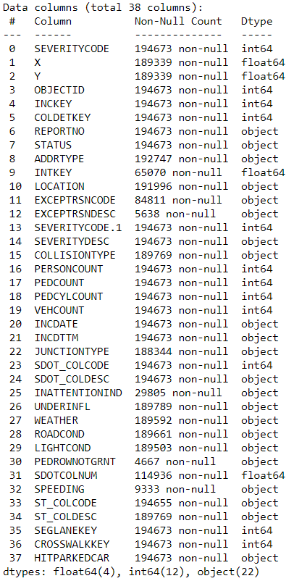

Our predictor or target variable will be 'SEVERITYCODE' because it is used measure the severity of an accident from 0 to 5 within the dataset. Attributes used to weigh the severity of an accident are 'WEATHER', 'ROADCOND' and 'LIGHTCOND'.

|  |  |
| --- | --- |
| Type | Description |
| 0 | Little to no Probability (Clear Condition) |
| 1 | Very Low Probability –Chance or Property Damage |
| 2 | Low Probability – Chance of Injury |
| 3 | Mid Probability – Chance of serious Injury |
| 4 | High Probability – Chace of Fatality |

### Processed Data

After filtering the dataset the dataset looks like

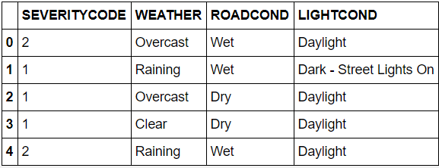

### Visualizing Data

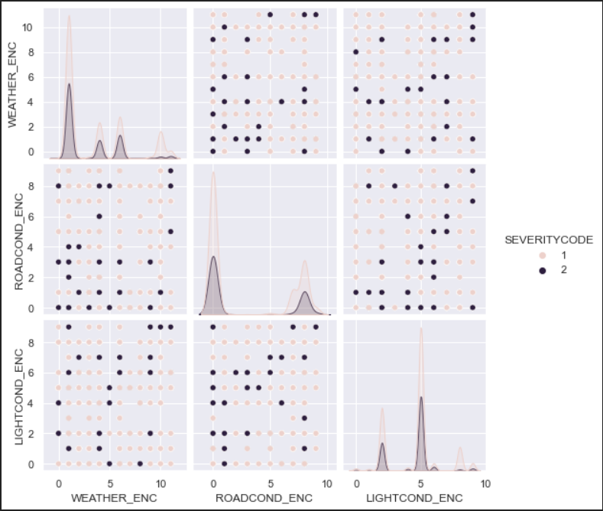

### Features

After processing the features and converting it from text to numerical form, features looks like

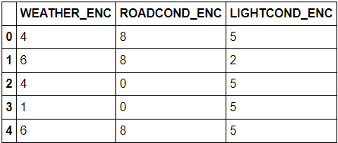

### Label

After processing the target, target looks like

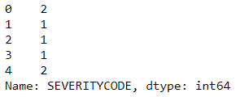

## Mythology

### KNN Supervised Clustering

KNN will help us predict the severity code of an outcome by finding the most similar to data point within k distance

## Results

KNN Model Accuracy: 69.78 %



## Conclusion

Based on historical data from weather conditions pointing to certain classes, we can conclude that particular weather conditions have a somewhat impact on whether or not travel could result in property damage (class 1) or injury (class 2).